

|  |  |  |  |  |  |  |  |  |
| --- | --- | --- | --- | --- | --- | --- | --- | --- |
|  | | | | | | | | |
|  | | DB LAB 04 | | | | |  | |
|  |  | | | | | | |  |
|  | | | |  |  | | | |
|  | | | | Basil Ali Khan(20K-0477) |  | | | |
|  | | | | 14 Sepetember 2022—Database and Management System Lab—Sir Ahmed Budhi |  | | | |
|  | | |  | | |  | | |

Task#01:

SELECT Employee_Id, First_Name, Salary, Department_Id

FROM HR.EMPLOYEES

WHERE Department_Id = 10

AND SALARY >= (SELECT MIN(Salary)

FROM HR.EMPLOYEES

WHERE Department_Id = 30);

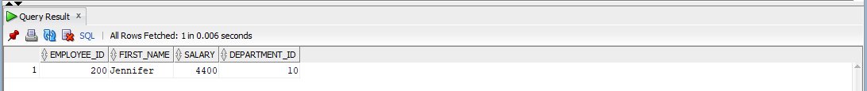

Task#02:

SELECT Employee_Id, First_Name, Salary, Department_Id

FROM HR.EMPLOYEES

WHERE Department_Id <> 30

AND SALARY > (SELECT MAX(Salary)

FROM HR.EMPLOYEES

WHERE Department_Id = 30);

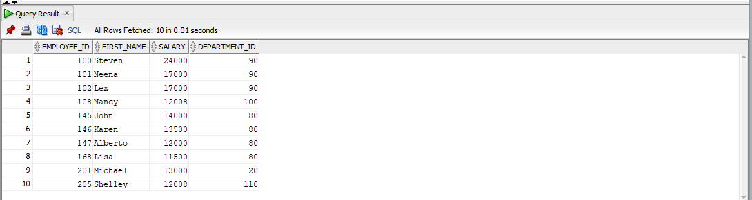

Task#03:

SELECT Department_Id

FROM HR.Employees

WHERE Department_Id NOT IN (SELECT Department_Id

FROM HR.EMPLOYEES);

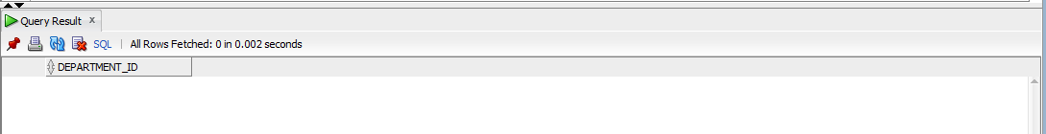

Task#04:

SELECT First_Name, Last_Name, Department_ID, Salary

FROM HR.EMPLOYEES

WHERE Department_Id IN (SELECT Department_Id

FROM HR.EMPLOYEES

WHERE Commission_Pct IS NOT NULL)

AND Salary IN (SELECT Salary

FROM HR.EMPLOYEES

WHERE Commission_Pct IS NOT NULL);

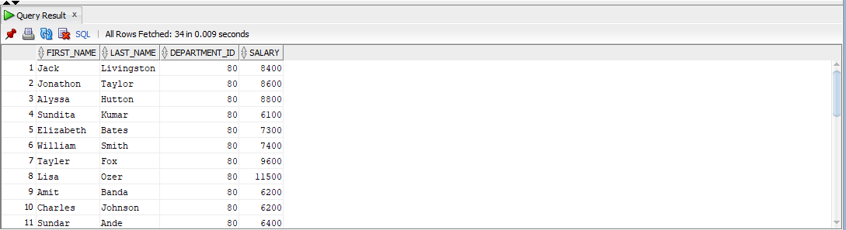

Task#05:

SELECT Department_Id, COUNT(Employee_Id) AS Total_Employees

FROM HR.EMPLOYEES

GROUP BY Department_Id;

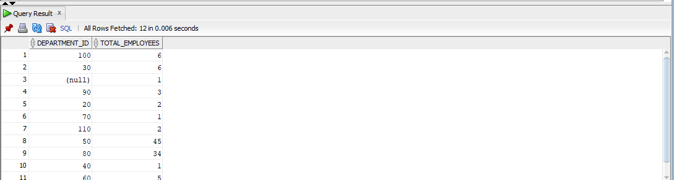

Task#06:

SELECT Department_Id, MAX(Salary) AS Maximum_Salary

FROM HR.EMPLOYEES

GROUP BY Department_Id

HAVING MAX(Salary) > 2900;

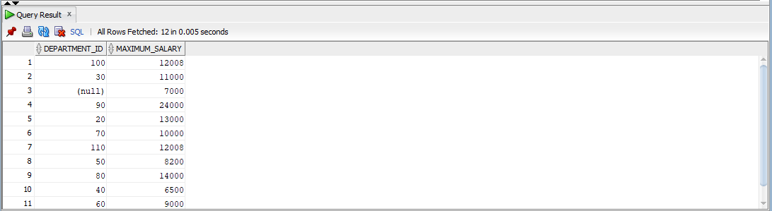

Task#07:

SELECT Job_Id, SUM(Salary) AS Total_Payroll

FROM HR.EMPLOYEES

WHERE job_id <> 'SA_MAN'

GROUP BY Job_Id

HAVING SUM(Salary) > 5000

ORDER BY SUM(Salary) DESC;

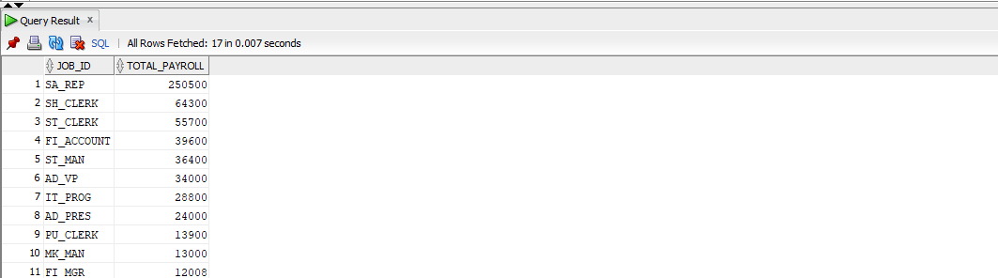

Task#08:

SELECT Department_Id, COUNT(Employee_Id) AS Number_Of_Employees

FROM HR.EMPLOYEES

GROUP BY Department_Id

HAVING COUNT(Employee_Id) > 3;

